EXPT NO: 9 | TEXT CLASSIFICATION AND TEXT GENERATION USING TRANSFORMERS
DATE: 1.11.26 | TEXT CLASSIFICATION AND TEXT GENERATION USING TRANSFORMERS

PRE-LAB QUESTIONS

1. What is a Transformer model in Natural Language Processing (NLP)?
A Transformer is a deep learning architecture used in Natural Language Processing. It uses an attention mechanism to understand relationships between words. It can process text efficiently and capture contextual information. It is widely used in classification and text generation.

2. What is BERT, and how is it used for text classification?
BERT stands for Bidirectional Encoder Representations from Transformers. It is a pretrained language model developed for understanding text. It reads words in both directions to understand context. It is used to classify text into categories such as positive and negative sentiments.

3. What is fine-tuning in the context of pretrained language models?
Fine-tuning is the process of adapting a pretrained model to a specific task. The model is trained further using a task-specific dataset. It adjusts its weights based on the new data. This improves its performance for the required application.

4. What is the difference between text classification and text generation?
Text classification assigns predefined categories or labels to input text. For example, it identifies positive or negative movie reviews. Text generation creates new text based on the given input. Examples include summarization and automatic text generation.

5. What is a sequence-to-sequence model, and how is it used in text generation?
A sequence-to-sequence model converts an input sequence into an output sequence. It generally consists of an encoder and a decoder. The encoder processes the input information. The decoder generates the output text based on that information.

AIM
To implement text classification by fine-tuning a pretrained BERT model and develop a simple sequence-to-sequence text generation application using Transformer models.

SOFTWARE REQUIREMENTS
- Python
- Google Colab
- Hugging Face Transformers
- Hugging Face Datasets
- PyTorch
- NumPy
- Pandas
- Matplotlib

OBJECTIVES
Students will be able to:
- Understand the architecture and working of Transformer models in NLP.
- Understand the concepts of text classification and text generation.
- Load and preprocess text datasets for NLP applications.
- Fine-tune a pretrained BERT model for text classification.
- Evaluate the classification model using appropriate performance metrics.
- Implement a sequence-to-sequence application using a pretrained Transformer model.
- Generate text using the model's text generation capabilities.
- Analyze and compare the outputs produced by the Transformer models.

PROCEDURE
PART A: DATASET PREPARATION AND TEXT PREPROCESSING
Perform the following tasks:
- Load a text dataset such as the IMDb movie review dataset.
- Explore the dataset and examine sample text entries and their labels.
- Check the number of samples and the distribution of class labels.
- Separate the dataset into training and testing sets or use the predefined splits.
- Load a pretrained tokenizer corresponding to the BERT model.
- Tokenize the text using the tokenizer.
- Apply padding and truncation to maintain consistent input lengths.
- Convert the tokenized data into the required format for model training.
- Prepare the dataset for batch-wise processing.
CODE:
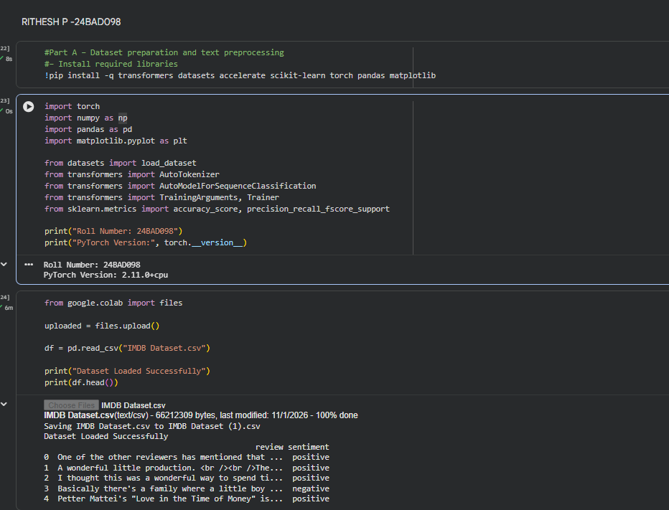
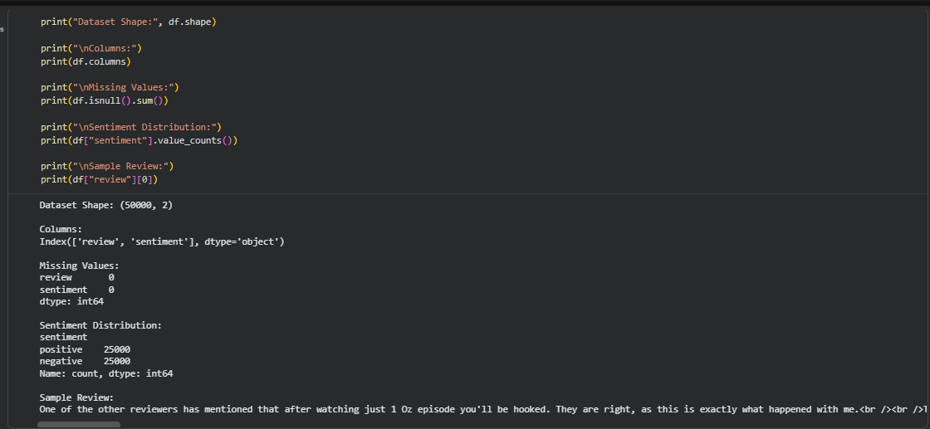
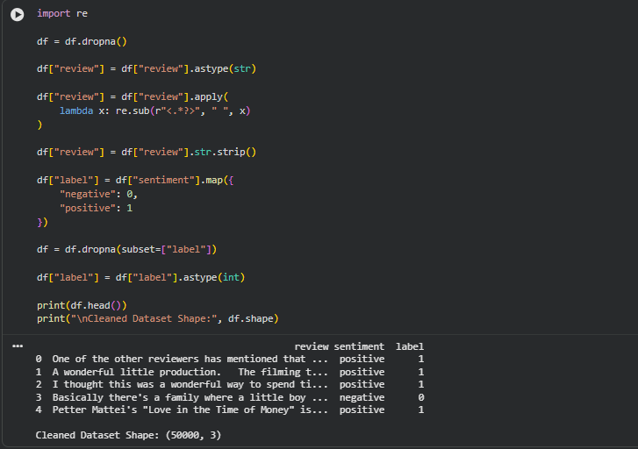
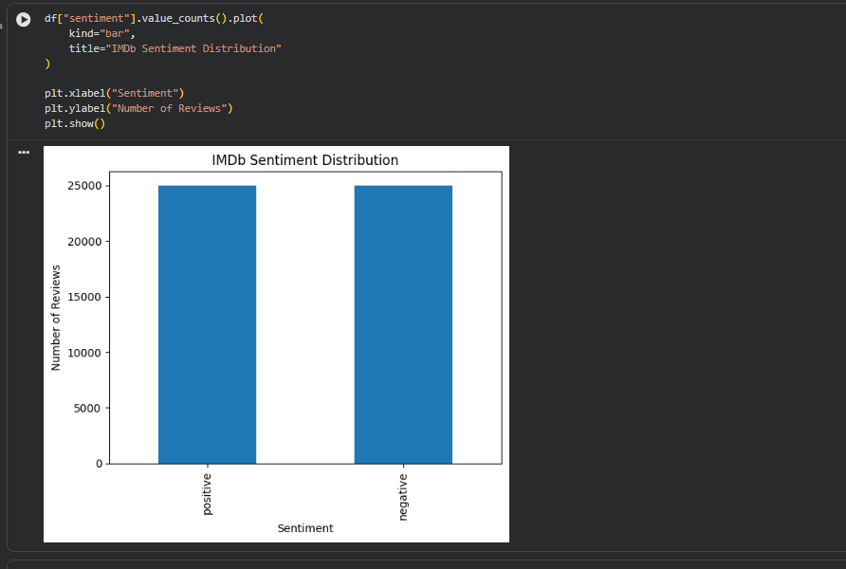
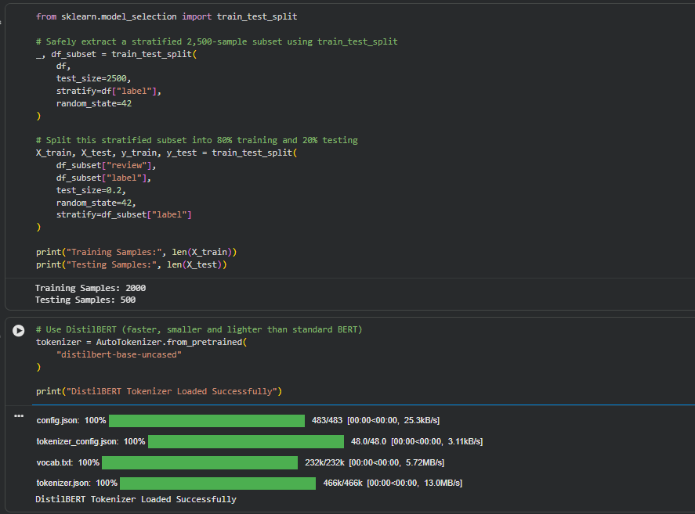
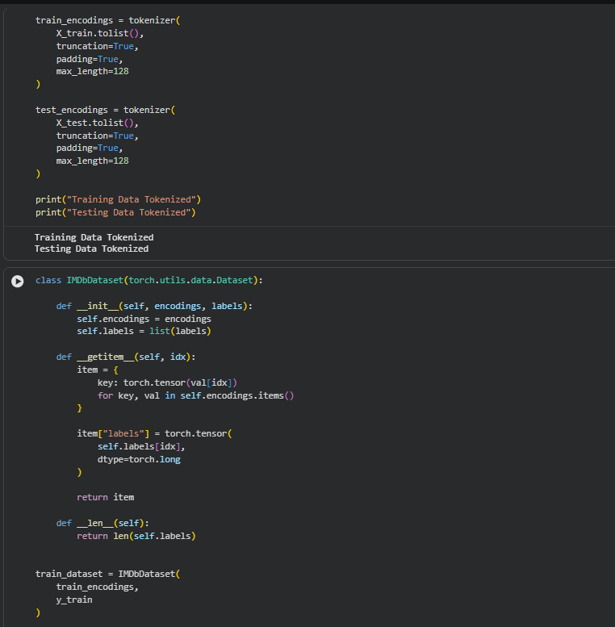
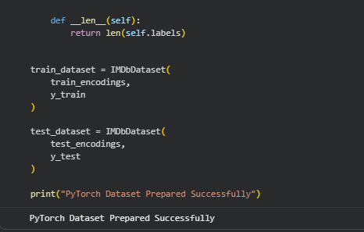

PART B: FINE-TUNING BERT FOR TEXT CLASSIFICATION
Perform the following tasks:
- Load a pretrained BERT model for sequence classification.
- Configure the model for the required number of classes.
- Prepare the tokenized training and testing datasets.
- Define the training parameters, including learning rate, batch size, and number of epochs.
- Fine-tune the BERT model using the training dataset.
- Evaluate the trained model using the testing dataset.
- Calculate appropriate performance metrics, such as accuracy, precision, recall, and F1-score.
- Test the model using new text inputs.
- Display the predicted class labels and corresponding evaluation results.
- Save the fine-tuned model and tokenizer.
CODE:
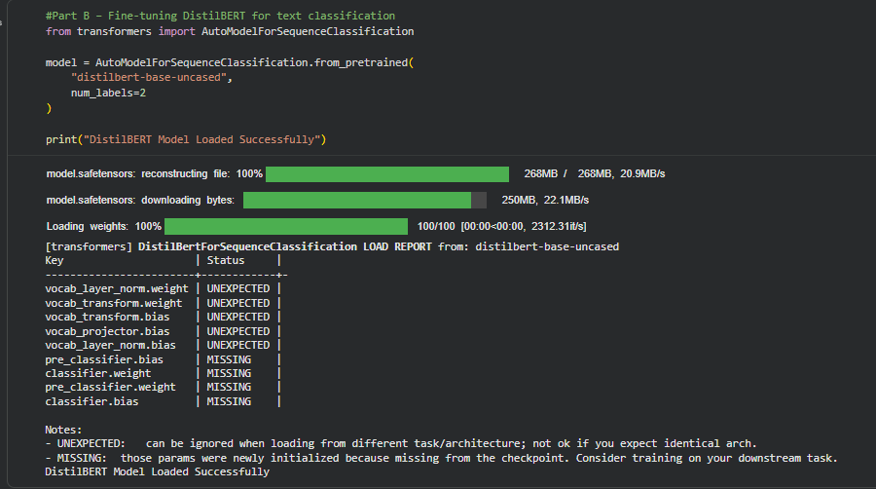
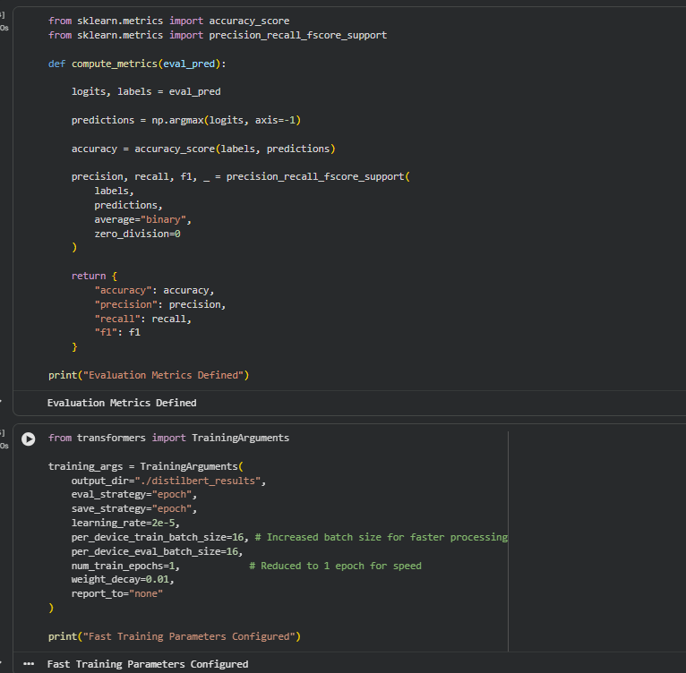
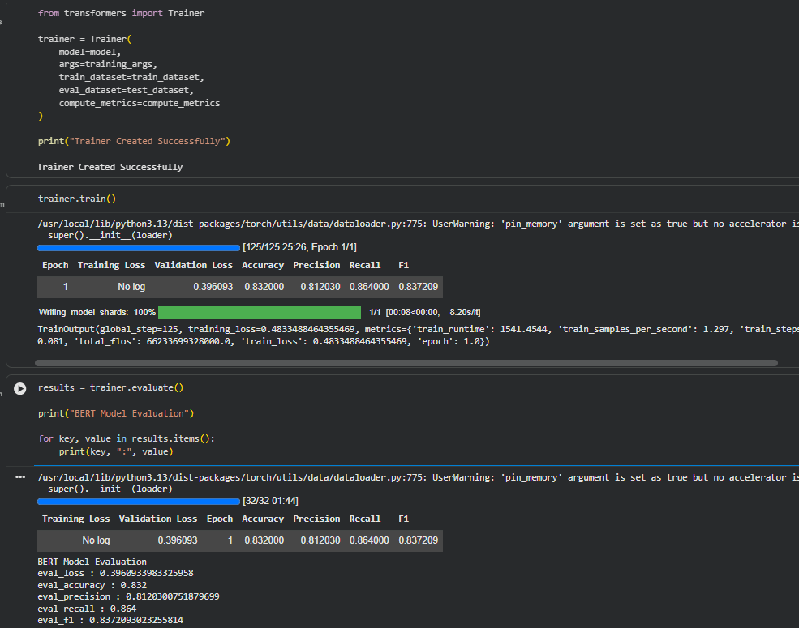
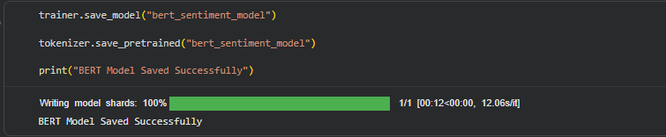

PART C: IMPLEMENTING A SEQUENCE-TO-SEQUENCE APPLICATION USING TRANSFORMERS
Perform the following tasks:
- Load a pretrained sequence-to-sequence Transformer model, such as T5-small.
- Load the corresponding tokenizer.
- Prepare a sample text input for the selected text generation task.
- Preprocess the input according to the model's requirements.
- Generate output text using the pretrained model.
- Apply appropriate generation parameters, such as maximum output length and beam search, where applicable.
- Display the input text and the generated output.
- Experiment with different input texts and generation settings.
- Observe how changes in the input and generation parameters affect the output.
- Save the generated outputs for further analysis.
CODE:
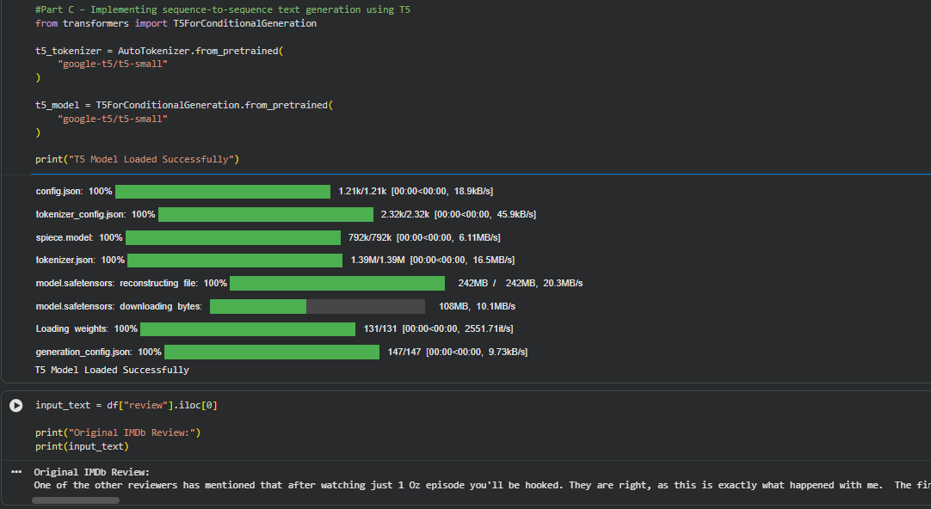
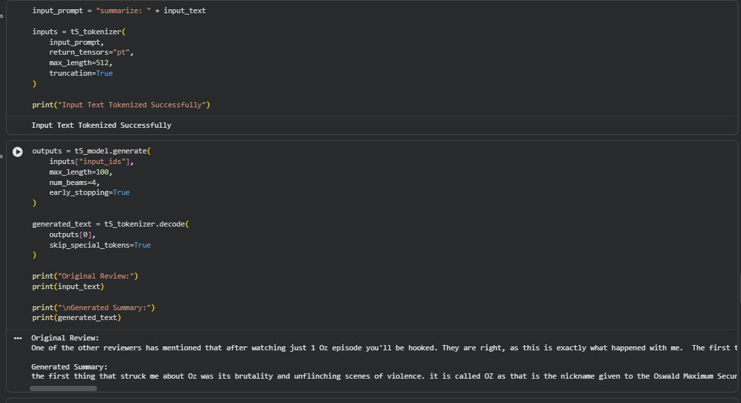
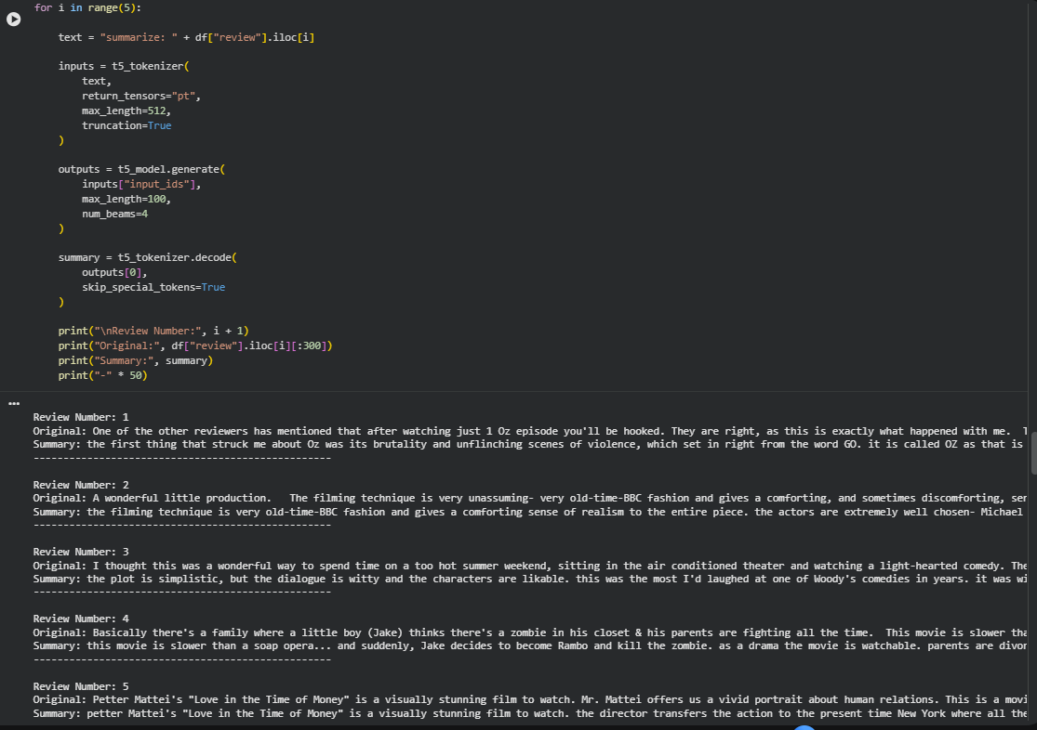
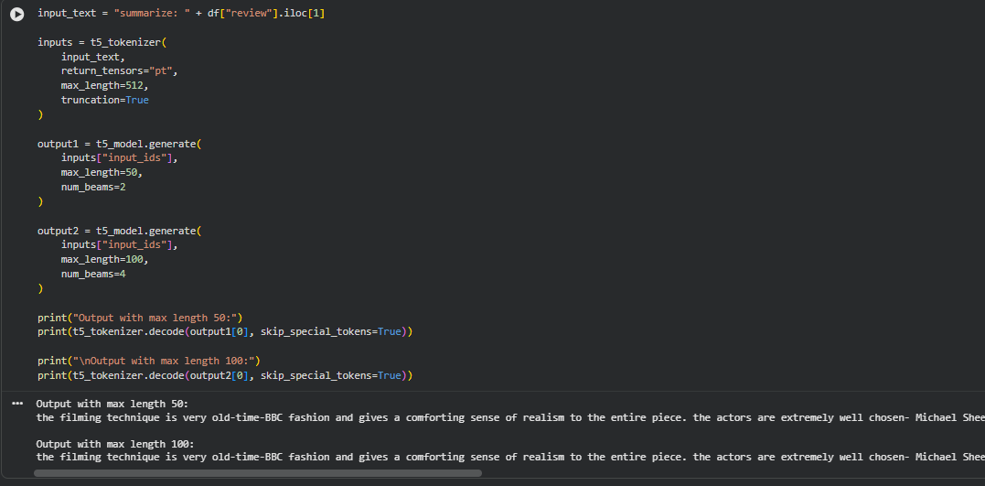

PART D: MODEL TESTING AND OUTPUT ANALYSIS
Perform the following tasks:
- Test the fine-tuned BERT model using sample positive and negative text inputs.
- Record the predicted class labels for the test inputs.
- Analyze the classification results using the selected evaluation metrics.
- Test the sequence-to-sequence model using different input texts.
- Compare the generated outputs for different inputs and generation settings.
- Examine the relevance, readability, and coherence of the generated text.
- Identify possible errors or limitations in the classification and generation outputs.
- Compare the applications of BERT-based classification and sequence-to-sequence text generation.
- Summarize the observations obtained from both models.
CODE:
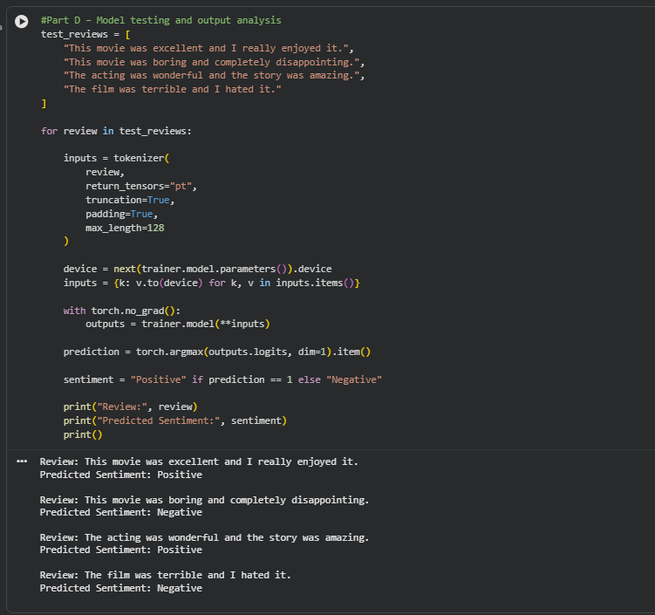
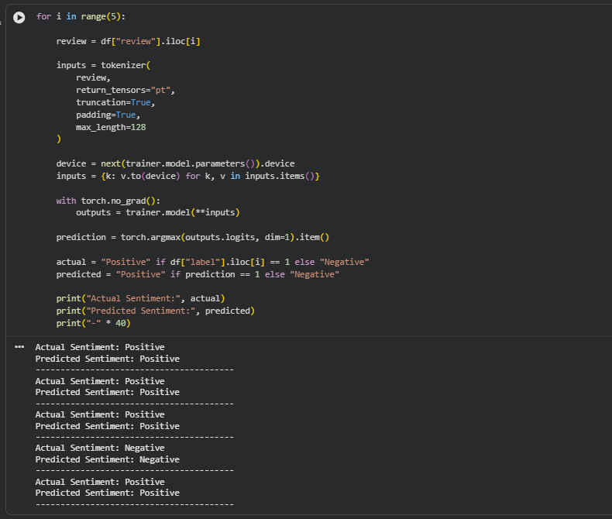
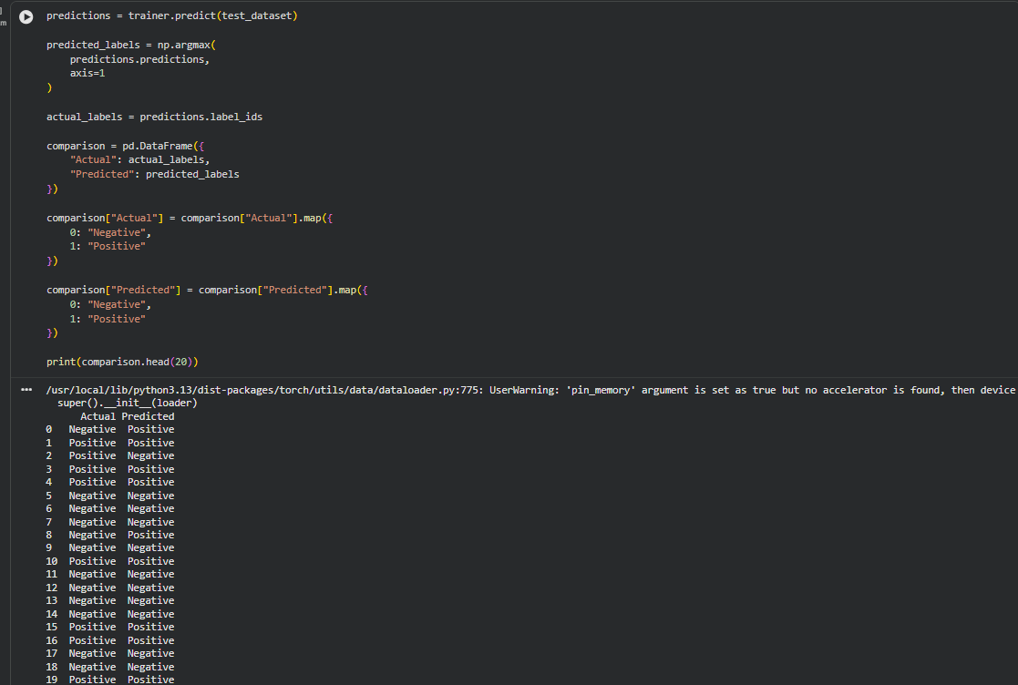
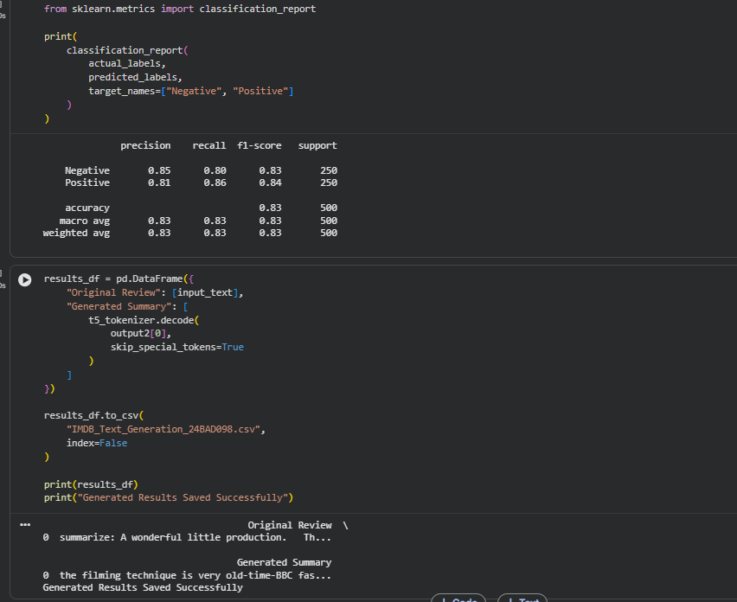

EXPECTED OUTCOME
Students will understand the architecture and applications of Transformer models in Natural Language Processing. They will learn to fine-tune a pretrained BERT model for text classification, preprocess textual data, and evaluate classification performance using appropriate metrics. Students will also develop a simple sequence-to-sequence text generation application using a pretrained Transformer model and analyze the quality and relevance of the generated outputs.

POST-LAB QUESTIONS

1. What is the role of BERT in text classification?
BERT is used to understand the context and meaning of input text. It processes words in both directions. It extracts meaningful features from the text. These features help classify reviews into categories such as positive and negative.

2. Why is tokenization required before providing text to a Transformer model?
Tokenization converts input text into smaller units called tokens. These tokens are converted into numerical IDs. Transformer models use these numerical representations as input. It helps the model process and understand text.

3. What is the purpose of fine-tuning a pretrained BERT model?
Fine-tuning adapts a pretrained BERT model to a specific task. It trains the model using task-specific data. The model updates its weights during training. This helps improve classification performance.

4. Mention any two evaluation metrics used for text classification.
Accuracy measures the percentage of correctly predicted results. Precision measures how many positive predictions are actually correct. These metrics help evaluate classification performance. They are commonly used in sentiment analysis.

5. What is the role of the encoder and decoder in a sequence-to-sequence Transformer?
The encoder processes the input sequence and extracts contextual information. It creates a representation of the input. The decoder uses this representation to generate output tokens. Together, they perform tasks such as text summarization and translation.

6. What is the difference between text classification and text generation?
Text classification assigns predefined labels to input text. It is used for tasks such as sentiment analysis. Text generation produces new text based on the input. It is used for summarization, translation and content generation.

7. How does the maximum output length affect text generation?
Maximum output length determines the maximum number of tokens generated. A smaller value produces shorter text. A larger value allows the model to generate longer text. It helps control the length of generated output.

8. Mention one real-world application of Transformer-based text classification and one application of text generation.
Sentiment analysis of customer reviews is an application of text classification. It identifies positive and negative opinions. Automatic text summarization is an application of text generation. It converts lengthy text into shorter summaries.

SUGGESTIONS FOR DATASETS & MODELS
Datasets:
- IMDb Movie Reviews – https://huggingface.co/datasets/stanfordnlp/imdb
- GLUE Benchmark – https://huggingface.co/datasets/nyu-mll/glue
- SST-2 Sentiment Classification – https://huggingface.co/datasets/nyu-mll/glue

Pretrained Models:
- BERT Base Uncased – https://huggingface.co/google-bert/bert-base-uncased
- T5-small – https://huggingface.co/google-t5/t5-small

ASSESSMENT
Description | Max Marks | Marks Awarded
Pre Lab Exercise | 5
In Lab Exercise | 10
Post Lab Exercise | 5
Viva | 10
Total | 30
Faculty Signature

